SESSION 05
Percentiles, Quartiles & Boxplots
Assignment Notes with Worked Demo

1. Percentiles

1.1 Definition
A percentile is a value below which a given percentage of the observations in a data set fall. The k-th percentile (Pk) splits the sorted data so that about k% of the values are at or below it and (100 − k)% are above it. For example, if a customer’s purchase is at the 90th percentile, 90% of purchases are smaller than or equal to it.

1.2 How to calculate a percentile
- Step 1: Sort the data in ascending order and note n, the number of observations.
- Step 2: Find the position of the percentile using the formula below.
- Step 3: If the position is a whole number, take that value. If it has a decimal part, interpolate between the two neighboring values.
Position of Pk = 1 + (n − 1) × (k / 100)
Note: textbooks use slightly different position formulas, so hand-calculated answers can differ a little. The formula above is the default method used by Python (NumPy), so the results match the demo in Section 6.

1.3 Example
Question: The marks of 11 students are: 12, 15, 17, 20, 22, 25, 28, 30, 35, 40, 95. Find the 10th and 90th percentiles.
Solution: The data is already sorted and n = 11.
- 10th percentile: position = 1 + 10 × 0.10 = 2, so P10 = 2nd value = 15.
- 90th percentile: position = 1 + 10 × 0.90 = 10, so P90 = 10th value = 40.

2. Quartiles

2.1 Definition
Quartiles are three values that divide sorted data into four equal parts, each holding about 25% of the observations. They are special percentiles.
Quartile | Percentile | Meaning
Q1 (lower) | 25th percentile | 25% of the values lie below Q1 and 75% lie above it.
Q2 (median) | 50th percentile | The middle value; half the data lies below it and half above.
Q3 (upper) | 75th percentile | 75% of the values lie below Q3 and 25% lie above it.

2.2 Five-number summary
The five-number summary describes the spread of a data set using the minimum, Q1, median (Q2), Q3 and the maximum. It is exactly the information a boxplot displays.

2.3 Example
Question: Using the 11 marks above, find the quartiles.
Solution: Q1 position = 1 + 10 × 0.25 = 3.5, so Q1 = (17 + 20) / 2 = 18.5. Q2 position = 6, so Q2 = 25. Q3 position = 1 + 10 × 0.75 = 8.5, so Q3 = (30 + 35) / 2 = 32.5.
Five-number summary = {12, 18.5, 25, 32.5, 95}

3. Interquartile Range (IQR)
The IQR measures the spread of the middle 50% of the data. It is the distance between the third and the first quartile.
IQR = Q3 − Q1

Why IQR is useful
- Robust: it ignores the lowest 25% and highest 25% of values, so extreme values do not affect it.
- Better than range for skewed data: the range uses only the minimum and maximum and is distorted by one extreme value.
- Basis of outlier detection: the IQR is used to build the fences that flag unusual values (Section 4).

Example
Solution: For the 11 marks, IQR = Q3 − Q1 = 32.5 − 18.5 = 14. The middle 50% of students scored within a spread of 14 marks.

4. Outlier Detection
An outlier is an observation that lies unusually far from the rest of the data. The most common rule, called Tukey’s 1.5 × IQR rule, defines two fences. Any value outside the fences is treated as an outlier.
Lower fence = Q1 − 1.5 × IQR
Upper fence = Q3 + 1.5 × IQR
- A value below the lower fence or above the upper fence is an outlier.
- The whiskers of a boxplot end at the smallest and largest values that are still inside the fences.

Example
Solution: For the 11 marks, Q1 = 18.5, Q3 = 32.5 and IQR = 14, so 1.5 × IQR = 21.
- Lower fence: 18.5 − 21 = −2.5. No mark is below this, so there are no low outliers.
- Upper fence: 32.5 + 21 = 53.5. The mark 95 is above this, so 95 is an outlier.

What to do with outliers
An outlier is not automatically an error. First check whether it is a data-entry mistake. If it is a genuine value, keep it but report the median and IQR instead of the mean, because the mean is pulled strongly by outliers.

5. Boxplots
A boxplot (box-and-whisker plot) is a graph of the five-number summary. It shows the centre, spread, skewness and outliers of a data set in a single compact picture, and is especially good for comparing several groups side by side.

5.1 Parts of a boxplot
Component | What it shows
Box | Runs from Q1 to Q3; its length is the IQR (the middle 50% of data).
Line inside the box | The median (Q2).
Whiskers | Extend to the smallest and largest values within the fences.
Points beyond whiskers | Outliers, plotted individually.

5.2 Reading a boxplot
- Median off-centre in the box: indicates skewness in the data.
- Longer whisker on one side: the data is stretched (skewed) toward that side.
- Wide box: high variability; narrow box means values are tightly clustered.
- Isolated dots: potential outliers that need investigation.

6. Demo: Create a Boxplot using Python

6.1 Problem statement
A store recorded the purchase value (in Rs.) of 15 customers. Find the quartiles and IQR, detect any outliers using the 1.5 × IQR rule, and draw a boxplot. The figures are illustrative for this demo.

6.2 Data
120, 150, 165, 180, 195, 210, 225, 240, 250, 265, 280, 300, 320, 350, 900 (n = 15)

6.3 Python code
import numpy as np
import matplotlib.pyplot as plt

# Purchase values (Rs.) of 15 customers
data = np.array([120, 150, 165, 180, 195, 210, 225, 240,
250, 265, 280, 300, 320, 350, 900])

# Percentiles and quartiles
q1, q2, q3 = np.percentile(data, [25, 50, 75])
p10, p90 = np.percentile(data, [10, 90])

# IQR and outlier fences
iqr = q3 - q1
lower = q1 - 1.5 * iqr
upper = q3 + 1.5 * iqr
outliers = data[(data < lower) | (data > upper)]

print("Min:", data.min(), " Max:", data.max())
print("Q1:", q1, " Median:", q2, " Q3:", q3)
print("10th percentile:", p10, " 90th percentile:", p90)
print("IQR:", iqr)
print("Lower fence:", lower, " Upper fence:", upper)
print("Outliers:", outliers)

# Boxplot
plt.boxplot(data, vert=False)
plt.title("Boxplot of Customer Purchase Value")
plt.xlabel("Purchase value (Rs.)")
plt.show()

6.4 Output
Min: 120 Max: 900
Q1: 187.5 Median: 240.0 Q3: 290.0
10th percentile: 156.0 90th percentile: 338.0
IQR: 102.5
Lower fence: 33.75 Upper fence: 443.75
Outliers: [900]

6.5 Boxplot
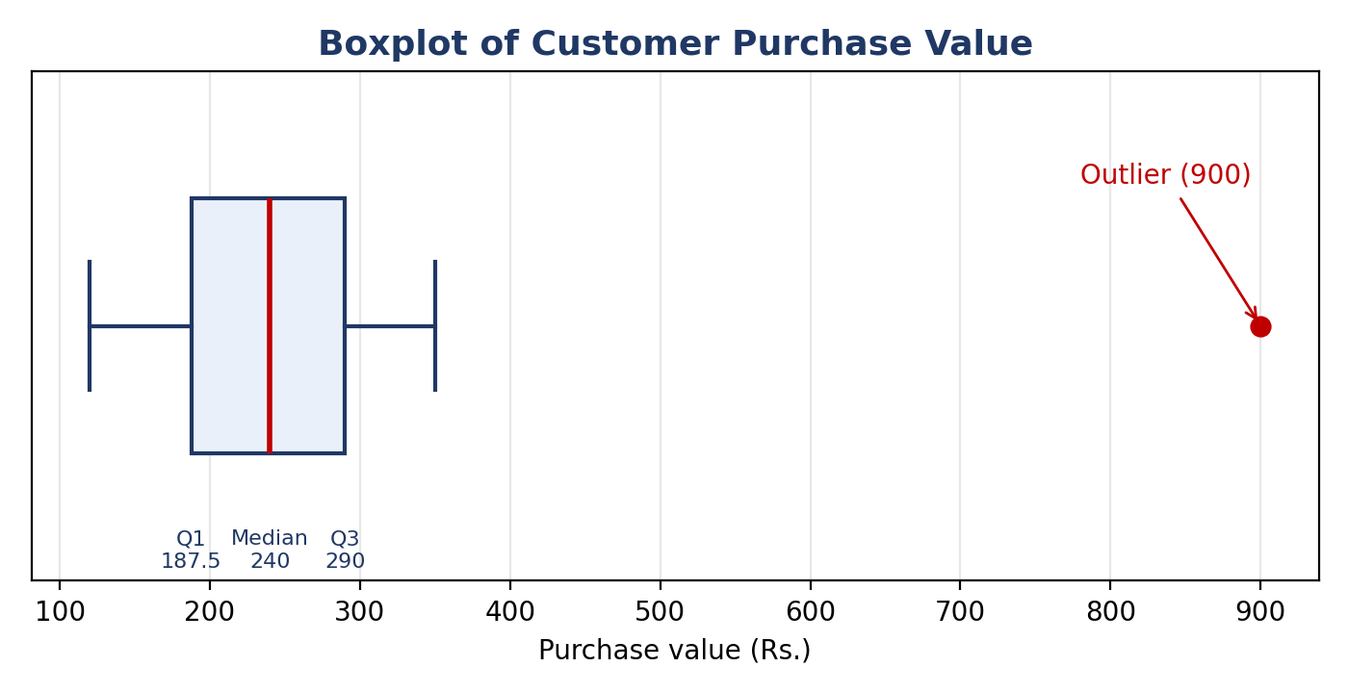
Figure 1: Boxplot of customer purchase value (the red dot is the outlier)

6.6 Manual verification
Measure | Calculation
Q1 | Position = 1 + 14 × 0.25 = 4.5, so (180 + 195) / 2 = 187.5
Median (Q2) | Position = 1 + 14 × 0.50 = 8, so 8th value = 240
Q3 | Position = 1 + 14 × 0.75 = 11.5, so (280 + 300) / 2 = 290
IQR | 290 − 187.5 = 102.5
Lower fence | 187.5 − 1.5 × 102.5 = 33.75
Upper fence | 290 + 1.5 × 102.5 = 443.75

6.7 Interpretation
- Centre: the median purchase is Rs. 240, and the middle 50% of customers spend between Rs. 187.5 and Rs. 290.
- Spread: the IQR is Rs. 102.5, so typical spending varies moderately.
- Outlier: the purchase of Rs. 900 is above the upper fence of 443.75, so it is flagged as an outlier. It may be a bulk or special order and should be checked before analysis.
- Whiskers: they stop at 120 and 350, the smallest and largest values inside the fences.
- Choice of measure: the mean (about Rs. 276.7) is pulled above the median by the outlier, so the median and IQR describe typical customers better here.

Key Takeaways
- Percentiles: the k-th percentile is the value below which k% of the data falls.
- Quartiles: Q1, Q2 and Q3 are the 25th, 50th and 75th percentiles.
- IQR: Q3 − Q1, the spread of the middle 50% of the data.
- Outliers: values below Q1 − 1.5 × IQR or above Q3 + 1.5 × IQR.
- Boxplot: a picture of the five-number summary, made in Python with plt.boxplot().

